Over the last 12 months the Forum has held the following meetings, all in St Peter’s Centre:

CHESTER WORLD DEVELOPMENT FORUM

REPORT ON ACTIVITIES MAY 2012-MAY 2013

17th May 2012, CWDF AGM
The business meeting was followed by Forum member Terry green talking about his recent visits to Ethiopia and Uganda.

10th July 2012, Forum meeting
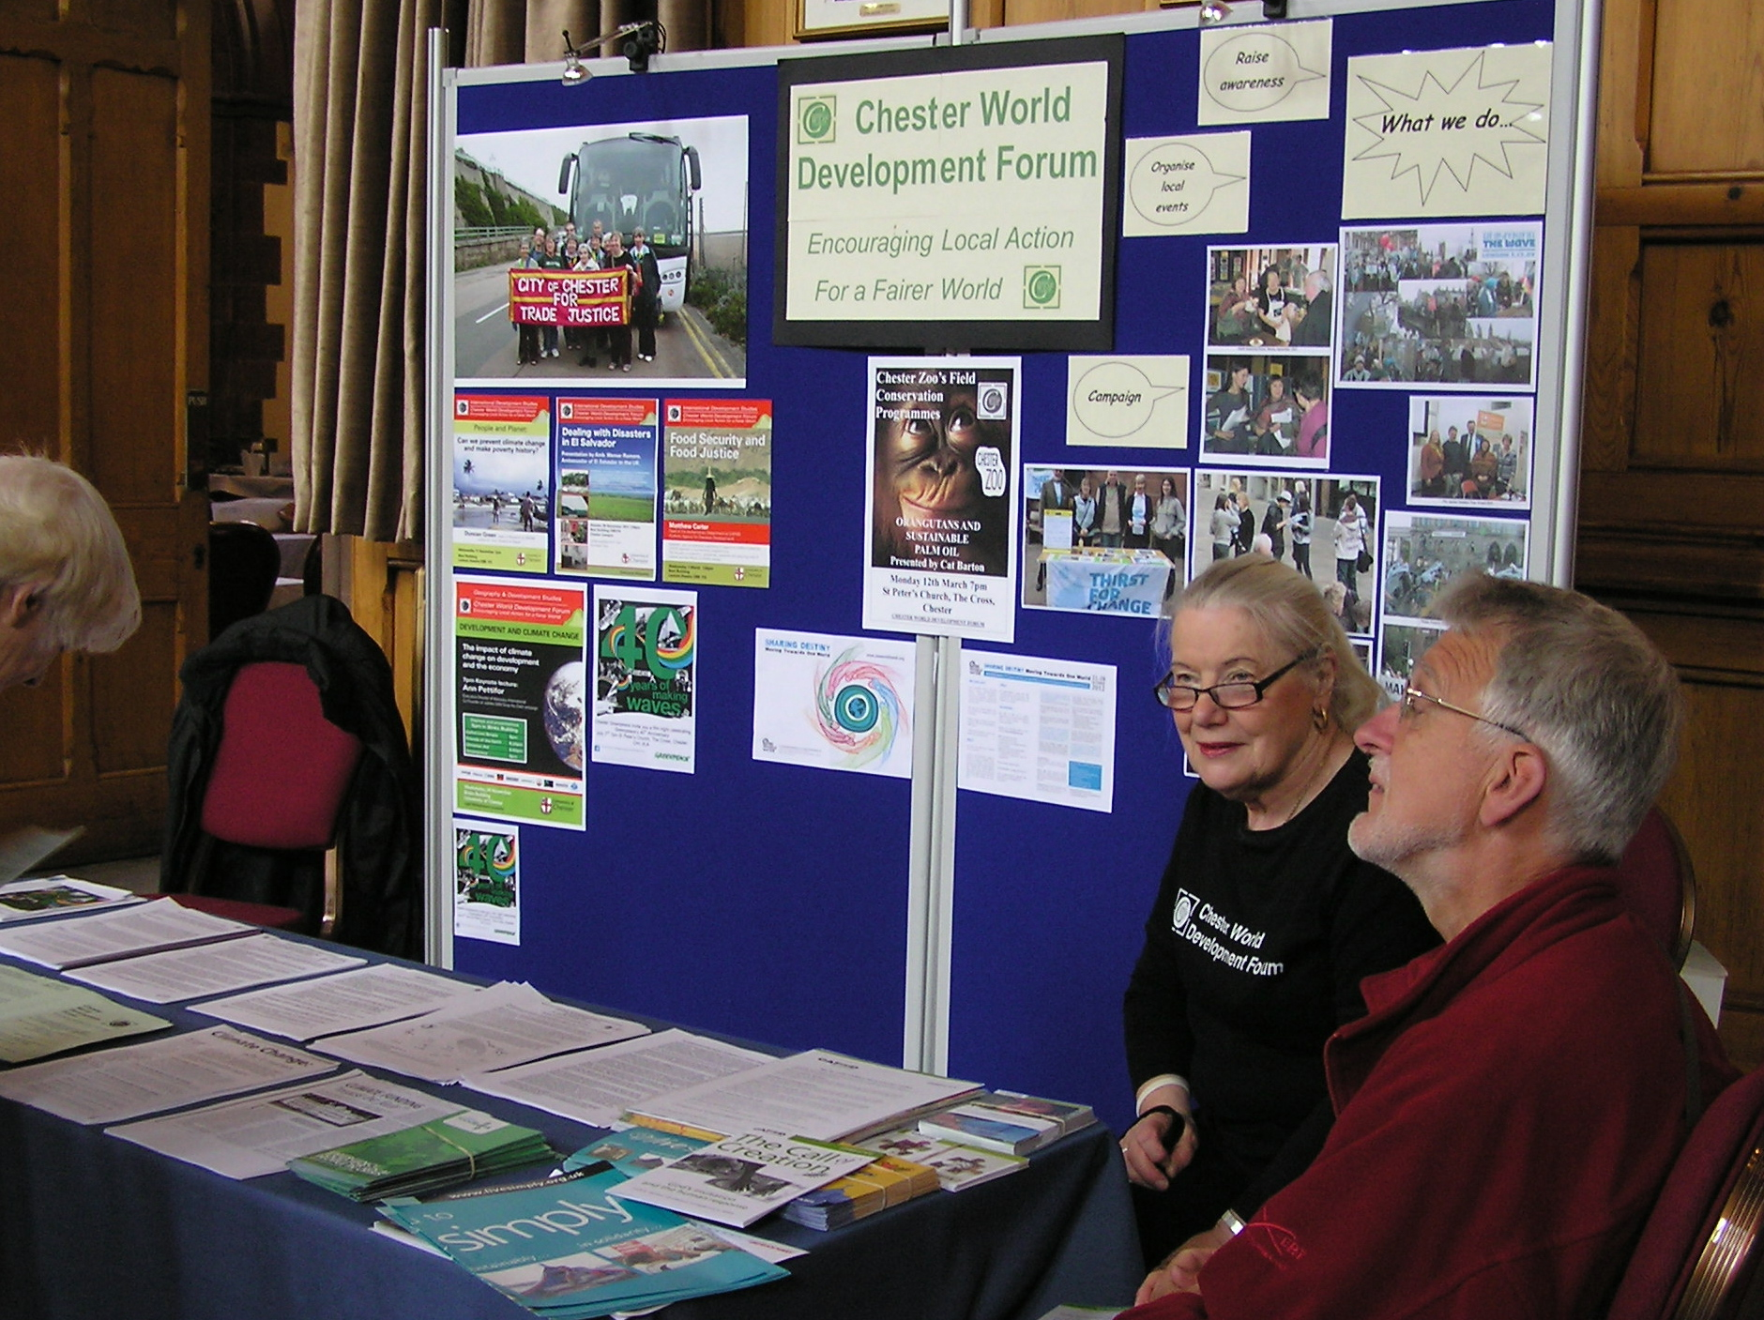
A different style of meeting called “Have Your Say” in which we were all given the opportunity of reflecting on the Forum’s first 19 years of existence and suggesting its priorities for the future. Subsequently, the Committee discussed the many issues that were raised, and suggested that our future activities should revolve around 4 broad strands:
- Environmental issues (climate change, clean energy)
- Tax justice (multi-nationals and tax evasion)
- Aid (millennium development goals, public perception of aid)
- Food security (land use, GM, biofuels, food banks)

10th September 2012, Forum meeting
Forum member Susan Flynn talked on Merseyside United Reformed Churches’ work over the years with the women of Malawi, going on to mention her own involvement in a new project using African fabrics in garment fashion.

12th November 2012, Forum meeting
Anne Herson talked about life and work in the favellas of Sao Paulo, Brazil.

14th January 2013, Forum meeting
Our speaker was Joan Bowers, talking about the work of the Baha’i community over the course of their 100 years in Britain and 50 years in Chester.

11th March 2013, Forum meeting
on Romy Tiongco’s work as Mayor of Damulog in the Philippines, plus an update on Christian

Aid’s forthcoming campaigns.

The Forum has been able to play an active part in a number of other events:

23rd June 2012, Chester Green Day
This was a one-day event held in Chester Town Hall showcasing the work of a wide range of organisations involved in environmental and sustainability issues. The Day was organised by Transition Chester, and it coincided with the UN’s “Rio + 20” event, the conference on Sustainable Development held in Rio de Janeiro 20 years on from the 1992 Earth Summit.
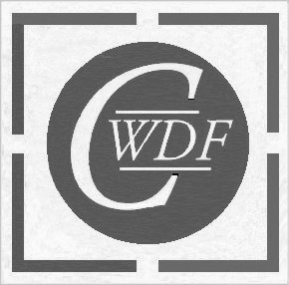
Our working relationship with the University of Chester’s Department of Geography and Development Studies continues to flourish, giving us further opportunities. Once again we acknowledge the support given by Gill Miller in promoting the shared experience, and jointly promoting notable talks:

23rd November 2012
A talk to students, Forum members and the wider public by Stephen O’Brien, MP for the Cheshire constituency of Eddisbury and formerly Parliamentary Under Secretary of State for International Development.

29th January 2013
A talk by Duncan Green, Senior Strategic Adviser to Oxfam, on the theme “What’s Hot and What’s Not in Development”. This talk came shortly after the publication of the 2nd edition of his book “From Poverty to Power, and was attended by a large, very mixed-age audience.
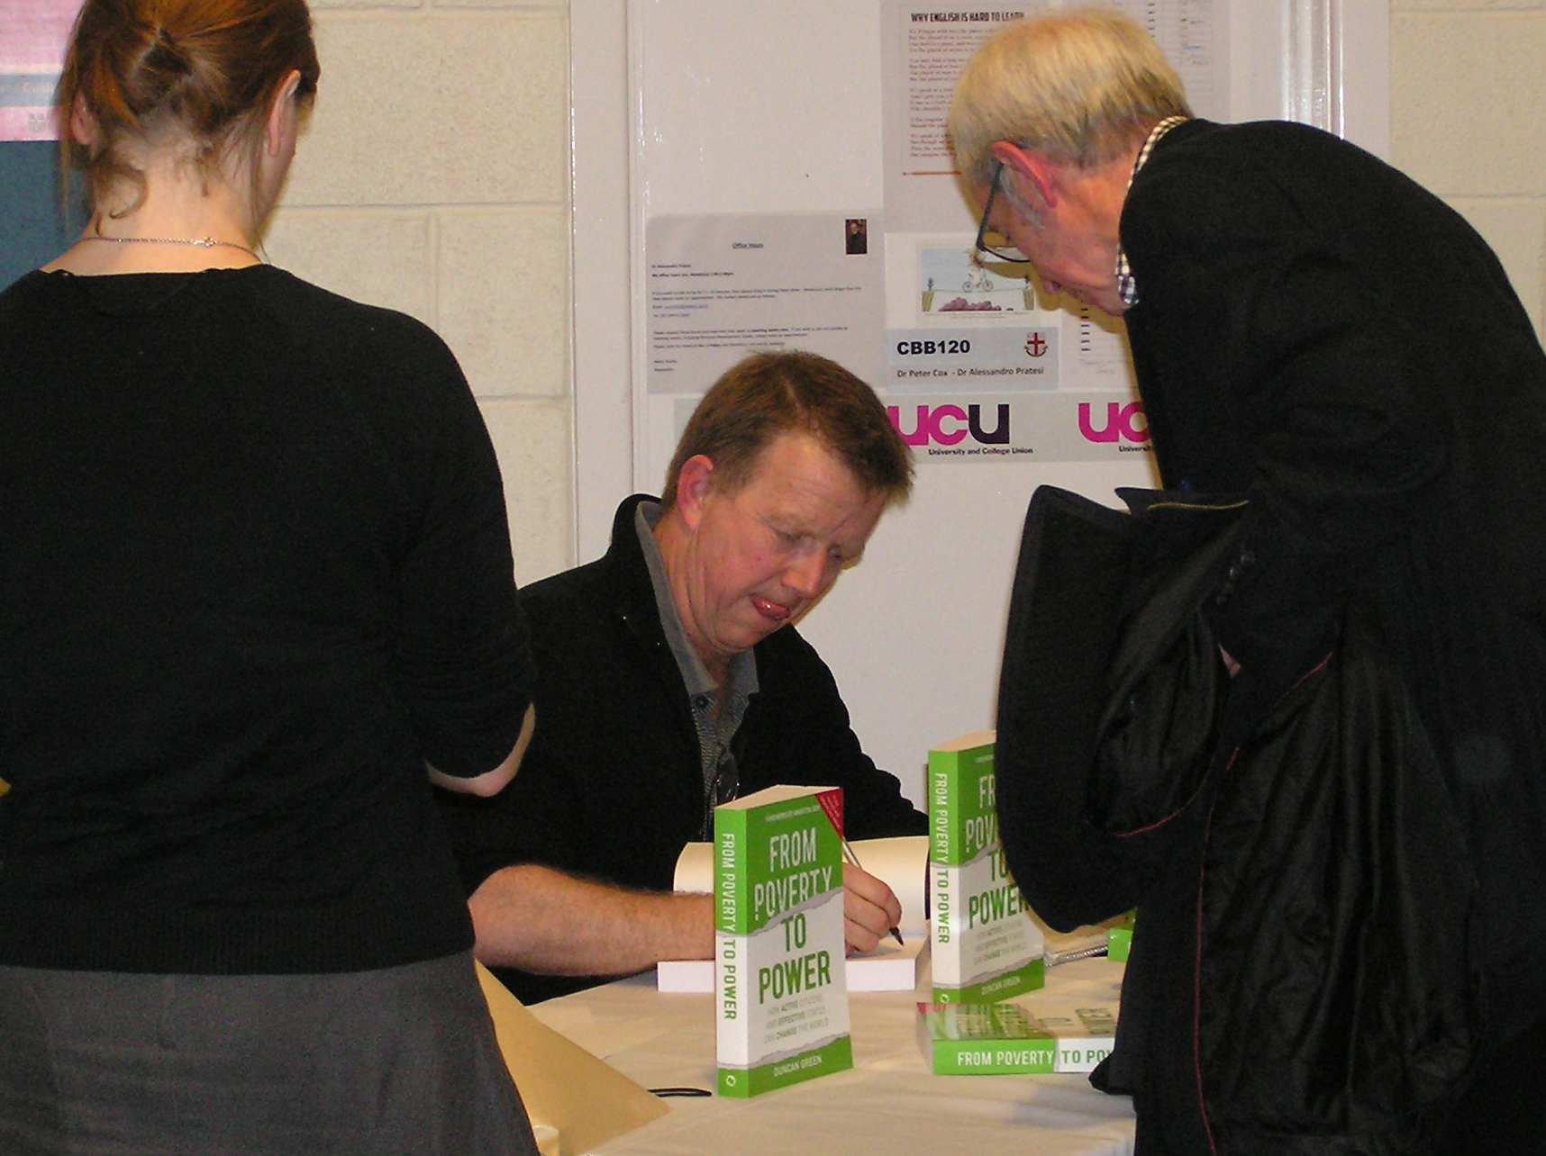
Tax Justice
Our main campaigning activity in the last 12 months included the organising of a welcome and associated meeting for Christian Aid’s “Tax Bus” which toured Britain and N Ireland in autumn 2012. The Chester visit was on 13th October when the Bus parked up on Castle Square and a meeting held in St Mary’s Centre, addressed by speakers from Christian Aid and Church Action on Poverty. Thanks are due to Richard Johnson, the Forum’s main organiser for this event. We achieved an audience of around 50 (including our own MP, Stephen Mosley and a visit to the Bus by the Lord Mayor), quite an achievement for a Saturday evening.

The joint work of Christian Aid and Church Action on Poverty has achieved a remarkable increase in the level of awareness of the different forms of tax evasion, here in Britain and in the developing countries. It is true to say that, as a result of the campaigning efforts, a number of large international companies are feeling the heat.

Food Matters
Campaigns for 2013 stay with Tax Justice but also focus on themes to be covered in the June 2013 meeting of the G20 leaders, being held in Northern Ireland and on the aims of the “IF” campaign. For its part, the Forum will be holding a one-day conference “Food Matters” at the University of Chester on 16th November 2013. The day will include a number of keynote speakers, and four workshops reflecting the four aspects of the “IF” campaign. We hope that Forum members will give strong support to this event.

Forum Income & Expenditure
We keep our subscription levels low, to cover our own administration expenses. However, we have been lucky to benefit from the energies of 2 of our members to boost our income:
- Richard Johnson kindly donated some of the proceeds of the regular series of “Cuppa Sundays” at St Peter’s Centre.
- Heather Lannin found ways to ensure that some of the “open mic” events at Alexander’s cafe bar were held in support of CWDF causes.
These extra sources of income allowed us to respond to certain crisis appeals from the Disasters Emergency Committee and Oxfam.

Communications
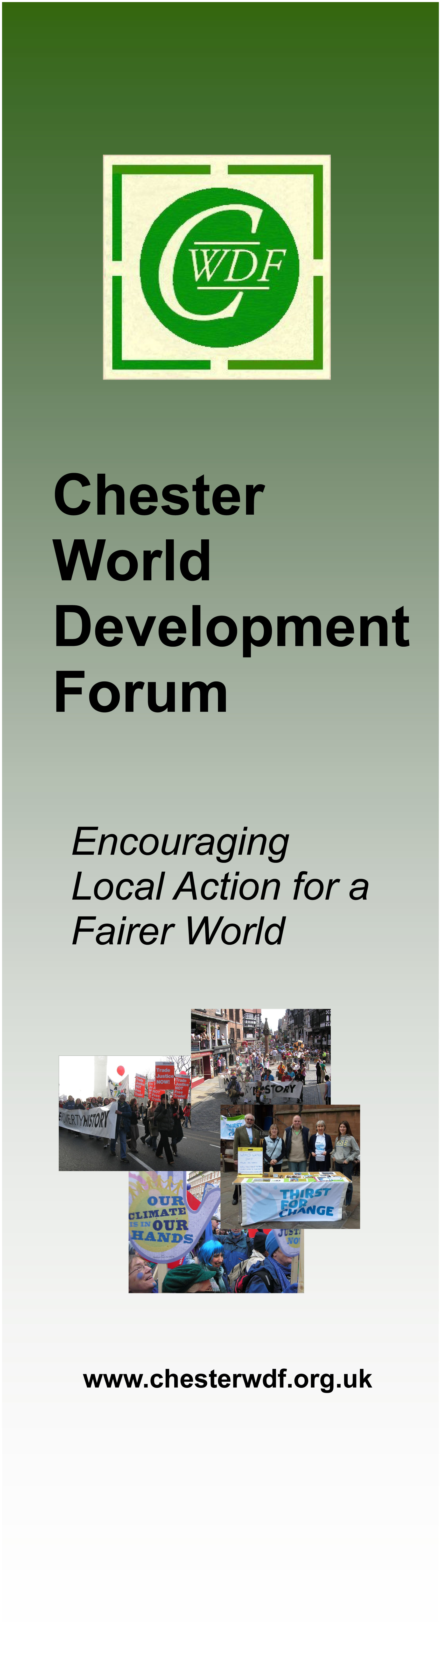
In addition to our regular mailings to our full members (33 organisations and 28 individual members) we send our Diary updates and other event notifications via email on to a larger circle of interested people. This system has proved very effective.
Lately, our website has become somewhat moribund due to the move of our adviser and website host George Cooke away from Chester. We are now in the process of renewing and upgrading the website, with technical support arranged via the “SkillShare” project administered through the CVA. We’re looking forward to the new site being up and running by autumn 2013.

Kath Stephenson & Bernard Payne
On behalf of CWDF Committee, May 2013

